COMPUTER PROGRAMING

EX NO -2

Name: Kakavakam Jaswanth Sai

Roll no: CH.EN.U4CSE20130

Section: CSE-B

Subject code: 19CSE102 LAB

EX NO -2: C CONTROL STRUCTURES

1. CO-PRIMES or NOT.

Aim:

To Write a program in C to check whether a given numbers are co-primes or not using while loop.

Algorithm:

Step 1: Start

Step 2: Declare three integral variables a, b, c, hcf, i.

Step 3: Input the values of a & b. and initialize the value of i to 1.

Step 4: calculate c = (a>b)? a: b.

Step 5: while i <= a

Step 6: if (a % i == 0 && b%i == 0) then store i value to hcf.

Step 7: increment the i value by one.

Step 8: End while.

Step 9: if hcf == 1 then print the both numbers are co primes.

Step 7: Stop

Program:

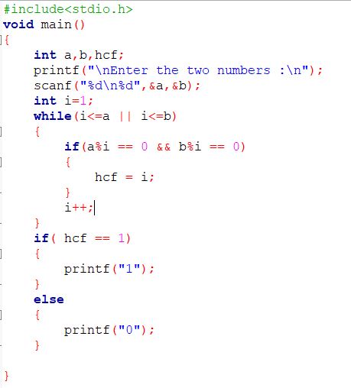

Output:

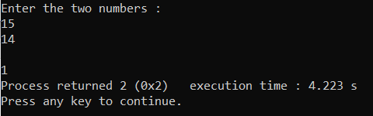 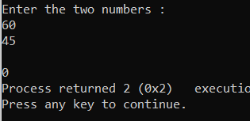

Result:

Thus the program to check whether a given numbers are co-primes or not using while loop with

C language has been executed and verified successfully.

1. ABUNDANT or NOT.

Aim:

To Write a program in C to check whether a given number is abundant number or not using **for loop.**

Algorithm:

Step 1: Start

Step 2: Declare three integral variables a, sum, i.

Step 3: Input the values of a & b. and initialize the value of sum to 0.

Step 4: for i=0;i<a and increment the i value by one.

Step 5: if (a % i == 0 ) then

Step 6: calculate sum=sum+i.

Step 7: End for.

Step 8: if sum is grater than “a” then print the “a” is an abundant number.

Step 9: else print the “a” is not a abundant number.

Step 7: Stop

Program:

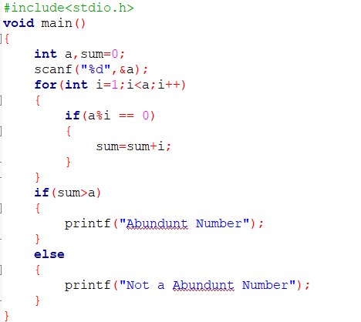

Output:

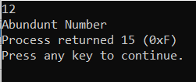 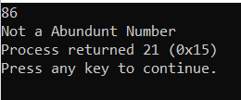

Result:

Thus the program to check whether a given number is abundant number or not using **for loop** with

C language has been executed and verified successfully.

1. SUM OF 1 TO N ODD NUMBERS.

Aim:

To Write a C program to find the sum of odd numbers from 1 to n using **do while loop**

Algorithm:

Step 1: Start

Step 2: Declare three integral variables a, sum, i.

Step 3: Input the values of a & b. and initialize the value of sum to 0.

Step 4: Do

Step 5: if ( i % 2 != 0 ) then

Step 6: calculate sum=sum+i.

Step 7: increment the i value by one.

Step 8: While (i<=a)

Step 9: print the sum.

Step 7: Stop

Program:

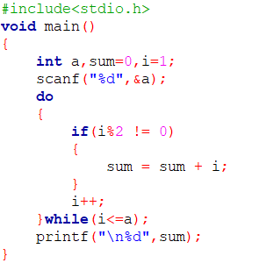

Output:

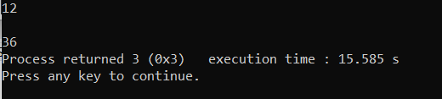

Result:

Thus the program to find the sum of odd numbers from 1 to n using **do while loop** with

C language has been executed and verified successfully.

1. SIMPLE CALCULATOR USING SWITCH CASE.

Aim:

To write a c program using **switch case** statement to output the following 2*3=6 ,2+3=5 ,4+6=10 ,4/5=0.8.

Algorithm:

Step 1: Start

Step 2: Declare three integral variables num1, num2,a.

Step 3: Input the values of num1 & num2.

Step 4: Ask the user for type of operation they need and get it as input for * = 1,+ = 2,- = 3, / = 4.

And store it to a

Step 5: by using switch case (a)

{

Case 1: calculate num1*num2 and print the value and stop.

Case 2: calculate num1+num2 and print the value and stop.

Case 3: calculate num1-num2 and print the value and stop.

Case 4: calculate num1/num2 and print the value and stop.

}

Program:

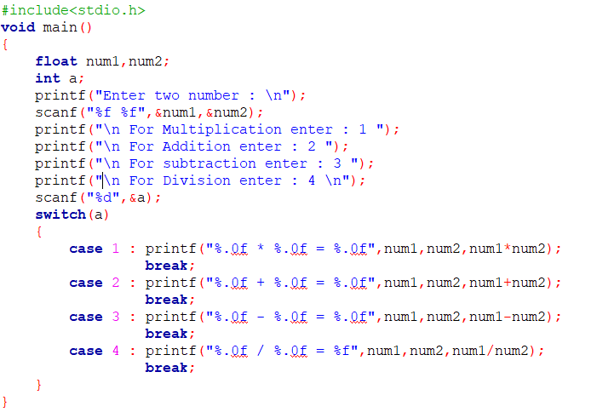

Output:

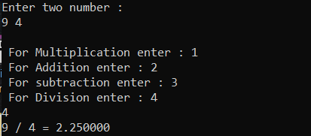

Result:

Thus the program using switch case for making simple calculator with C language

has been executed and verified successfully.

1. NESTED IF – ELSE IF -ELSE.

Aim:

To Write a program in C for the given scenario **( if –else if –else )**

Assign a value to double variable cost depending on the value of integer variable distance as follows:

**Distance Cost**

**----------------------------------- ----------**

0 through 100 5.00

More than 100 but not more than 500 8.00

More than 500 but less than 1,000 10.00

1,000 or more 12.00

Algorithm:

Step 1: Start

Step 2: Declare three integral variable dis and double variable cost.

Step 3: Input the values of dis.

Step 4: if (dis>0 && dis<=100) then cost =5.00.

Step 5: else if (dis>100 && dis<=500) then cost =8.00.

Step 6: else if (dis>500 && dis<1000) then cost =10.00.

Step 7: else the cost =12.00.

Step 8: calculate the total cost = dis*cost

Step 9: print the total cost.

Step 7: Stop

Program:

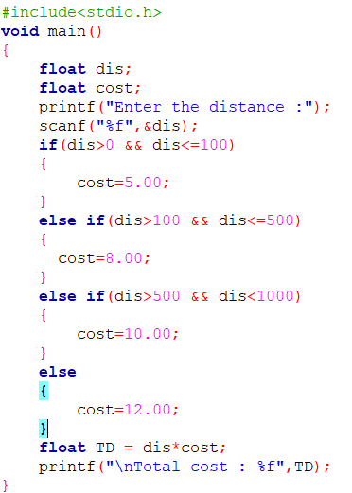

Output:

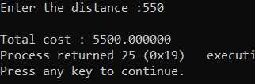

Result:

Thus the program for the given scenario using **if –else if –else in** C language

has been executed and verified successfully